MURAL PRICE SHEET
Budget: $10,000 minimum. Average prices $15-20,000.
My murals average roughly $45/square foot but prices vary widely based on complexity. Please email for an accurate quote itemized by:
- Supplies, including:
  - NovaColor Acrylic (specialty mural paint), ordered in bulk and custom-mixed,
  - Primer and Sealer based on wall material
  - Brushes, tarps, buckets, ladders and auxillary materials, most provided by artist
- Labor – including design composition, priming, painting and sealing as well as site and volunteer management. Figured per project at the rate of $75/hour or $600/day.
- Liability insurance
Additional costs may include travel outside of TriCounties, rental of scaffolding/lifts, extra wall preparation, working nights/weekends, and extended residencies with client groups.
Process: My murals are completely specialized to the client/organization, and typically include detailed and specific imagery around a chosen theme. Often I work with a group of volunteers, students, or employees to create this imagery through a “residency,” which can last from 2 hours to 3 months. Typically, two-three compositions are provided and approved before the big painting begins. I can also help with writing grants and press releases, organizing community paint-outs and securing volunteers and donations.
Copyright: Artist retains all copyrights to art, with the understanding that the mural will not be reproduced in total or at scale for any other project. Client may use art for advertising and reference purposes, but most negotiate a separate contract to use imagery on products or for-profit events. In the event of small graffiti or scratching, artist will provide fixes, free of charge, when notified by the client. Substantial damage necessitates a separate negotiation, with payment based on scope.
Payment: Preferred in three installments. 10% on contract signing, 40% when final composition is approved or two weeks prior to start date of painting, and remainder on completion.
Client Provides: Proof of ownership of the wall or signed easement form stating the mural will be protected for 5 years minimum. Any additional supplies on site are helpful, including: ladders, stepstools, water, and a sink for washing brushes. These optional donations or volunteer jobs also reduce costs:
- Wall-prep, including power washing and priming
- Donations of paintbrushes and rollers, primer and sealer, scaffolding and ladders
- Volunteer painters
- Donations of snacks, water, shade tents, sunscreen for painters.
- A planned celebration upon finishing
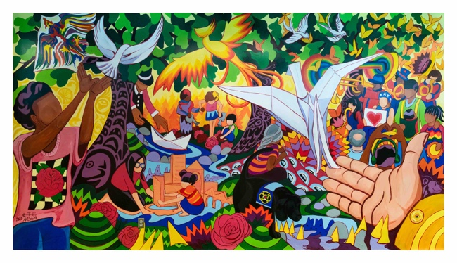
PROJECT COMPARISONS
Vibrant Cities Don’t Burn
Acrylic paint on Tyvek, 9x17 (145 square feet)
Budget: $12,000
2 rounds of designs: 60 hours
Painting offsite & install: 100 hours

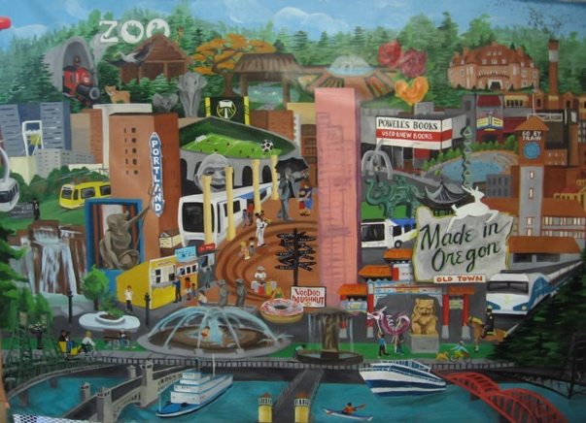
Portland I-Spy
acrylic on polyester curtain, 5’x9’ (45 square feet)
Budget $4500
100 hours painting off-site
This Design features multiple objects, places, and people in downtown Portland for children to find within. Citing of specific, realistic objects and people make a mural more expensive regardless of its finished size.

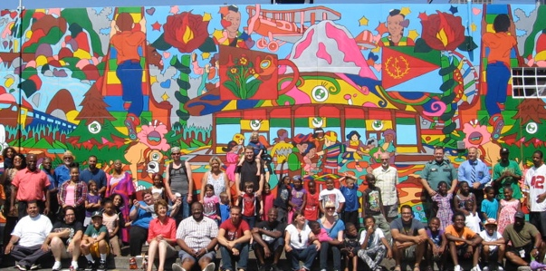
The Eyes of All
Acrylic on steel-plated wall, 14’x46’ (644 square feet)
Budget $12,000
12 days painting on-site
Though larger in scope, this mural’s cost was kept down with the deep involvement of the Rosewood Initiative, who donated $14,000 in in-kind funding, including water-jet wall cleaning, videography, scaffolding, restrooms and office space and 100+ community volunteers for the painting phase

Human Solutions Office Mural,
acrylic paint on wall, 60x11’ (660 square feet)
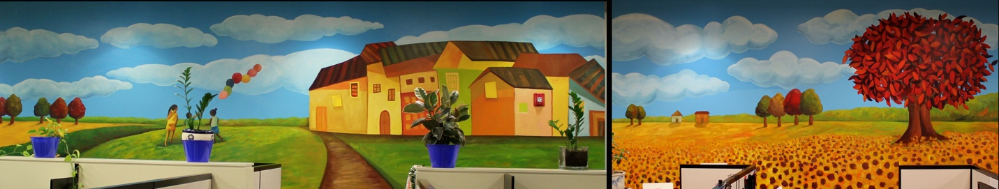
Budget: $4000
2 nights painting
This large wall focused on large shapes of colors, and artistic license by William Hernandez and I, and as such we could work much faster.

